**Hdfs Experiments**

**Introduction**

This file contains snapshots of HDFS commands and output in our Hadoop clusters. The experiments were carried in four Case studies focusing mainly on the Uptime and Storage of the namenode metadata.

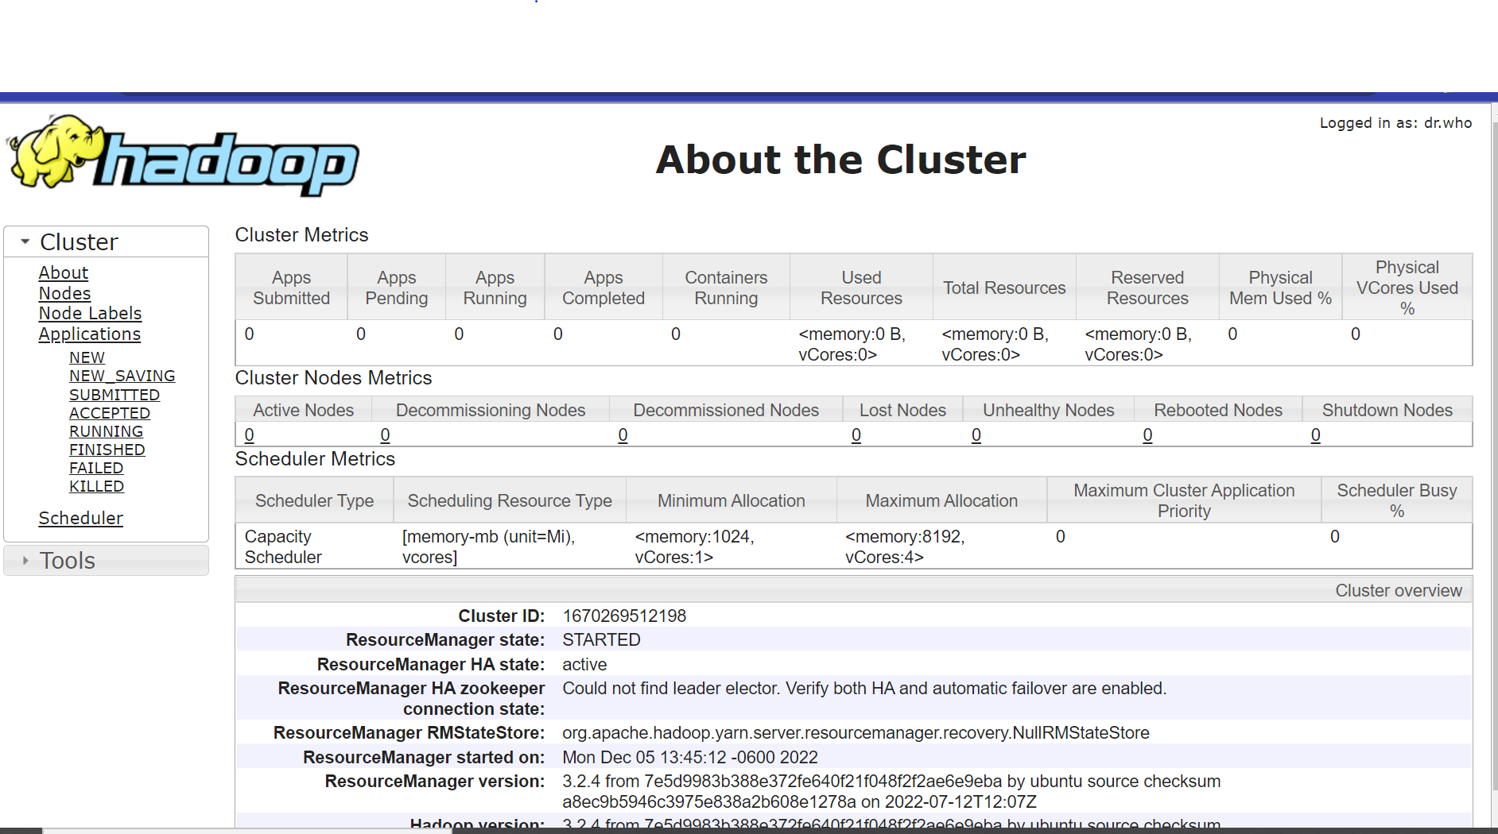

**Case 1: (1mb) Files.**

**Heap Memory**

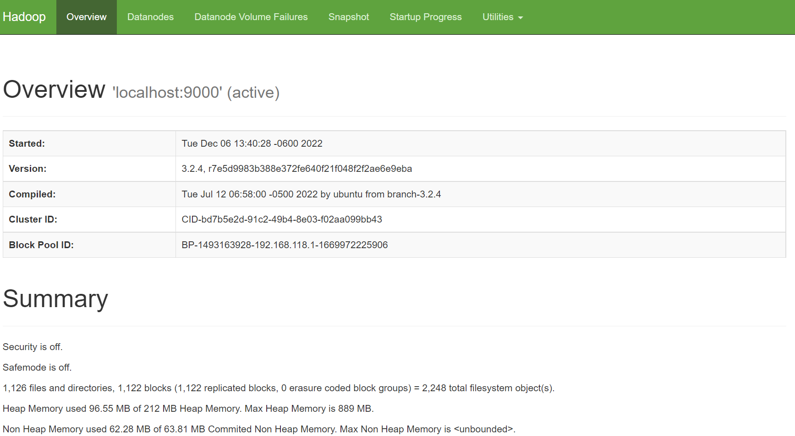

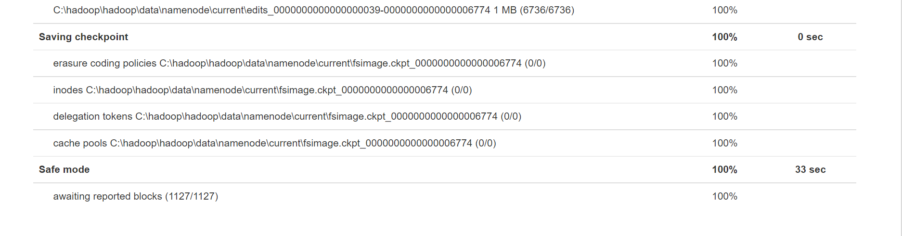

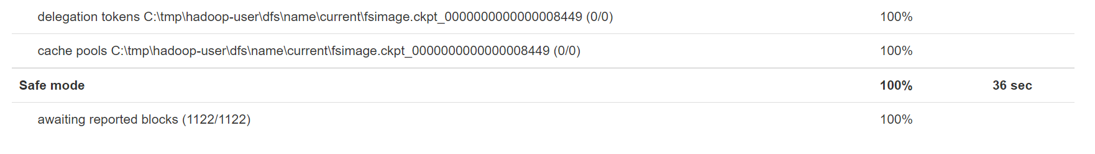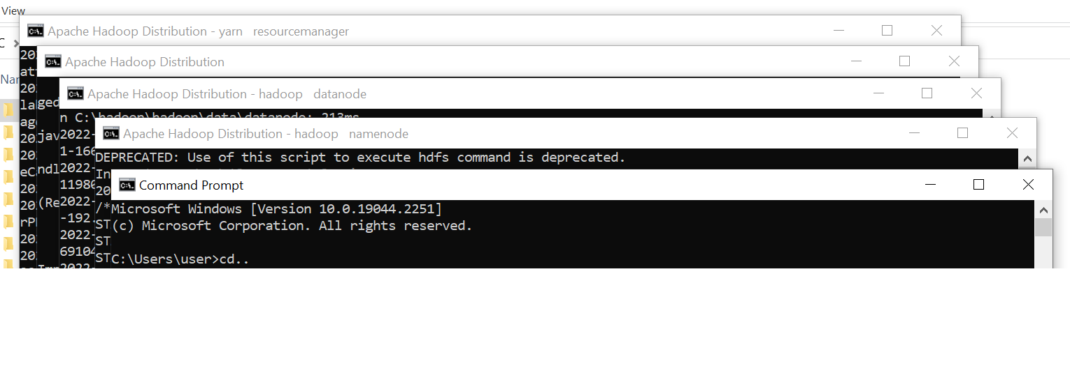

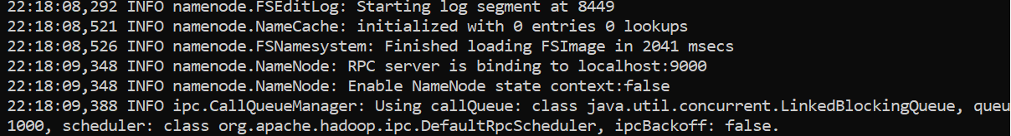

]



**Killed DataNode**

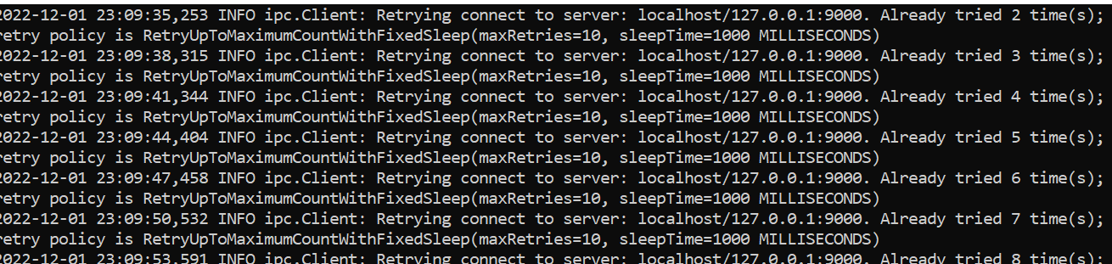

**Fixed The Datanode**

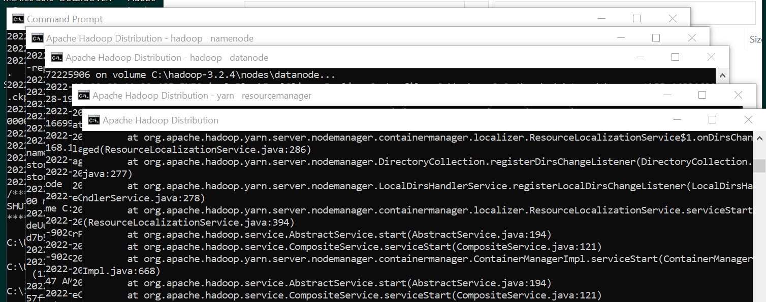

**Case 2 (4MB)**

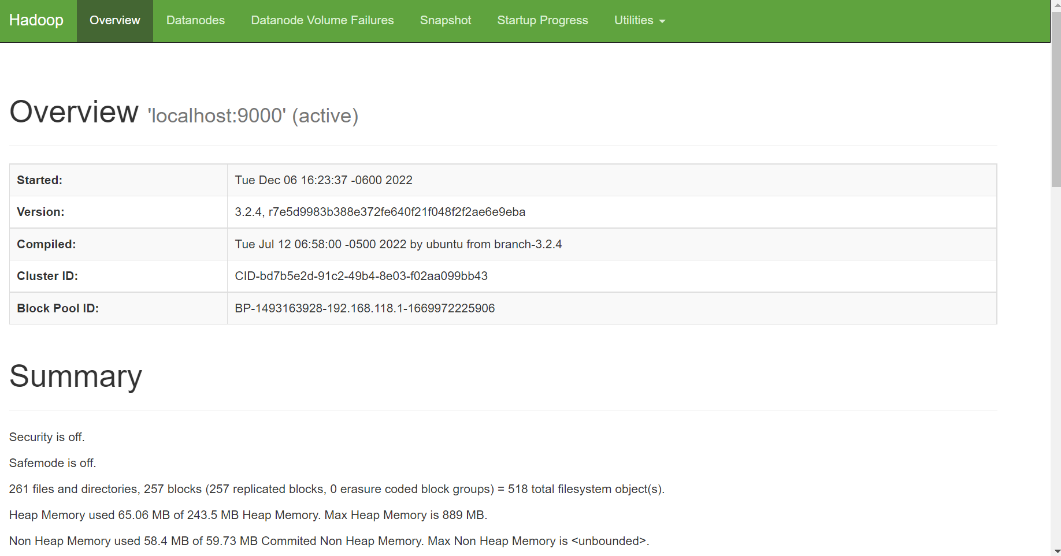

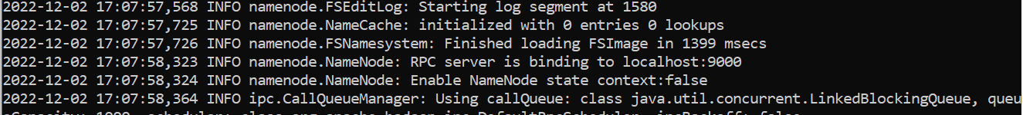

**Case 3 (154MB)**

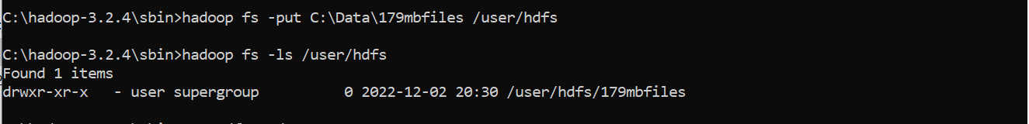

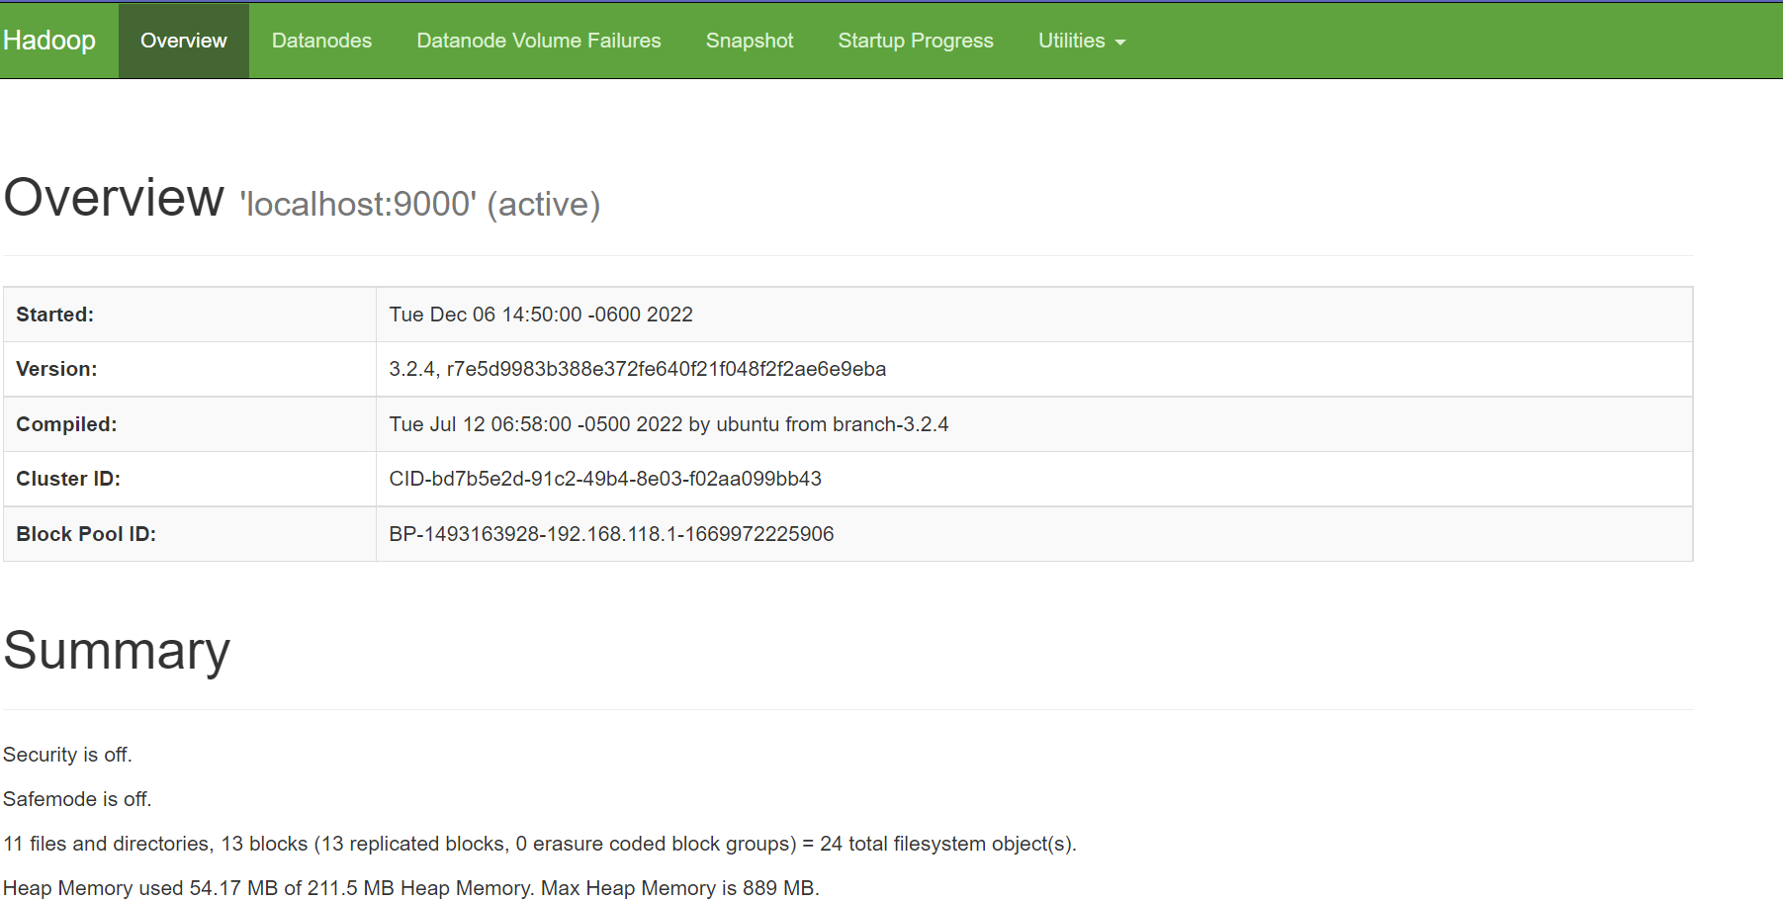



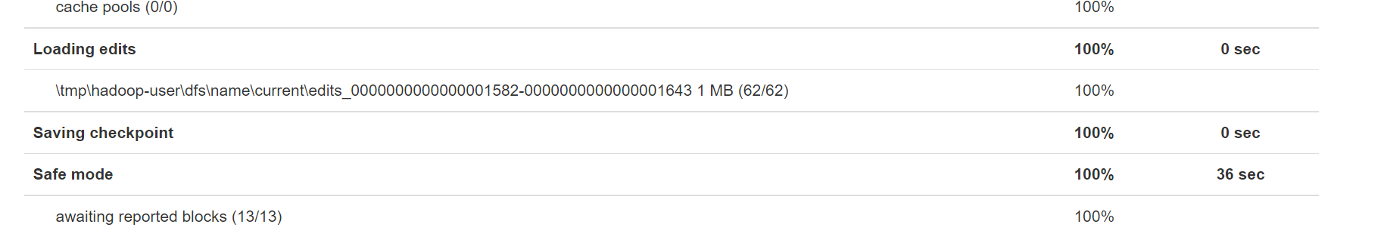

**Case 4: 1082MB (One File)**



